Experiment 1: Linear Search (Iterative)
- Aim: To analyze the time complexity of the linear search algorithm by searching for a given key element in an array using an iterative approach.
- Algorithm:
  - Start from the first element of the array.
  - Compare each element with the key value.
  - If the key matches an element, return its index.
  - If the key is not found after traversing the entire array, display a not found message.
PROGRAM
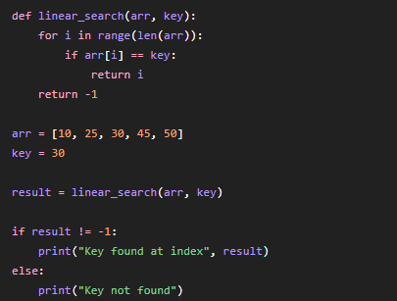

OUTPUT
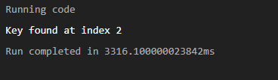
- Conclusion: Linear search is simple and easy to implement. It works well for small datasets but becomes inefficient for large datasets due to its O(n) worst-case time complexity.

Experiment 2: Binary Search (Recursive)
- Aim: To study the recursive implementation of binary search and analyze its logarithmic time complexity.
- Algorithm:
  - Find the middle element of the sorted array.
  - Compare it with the key.
  - If equal, return the index.
  - If the key is smaller, recursively search the left half.
  - Otherwise, recursively search the right half.
PROGRAM
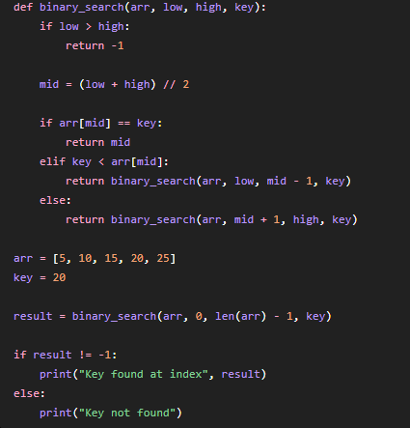
OUTPUT
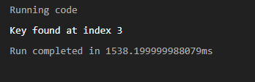
- Conclusion: Binary search significantly reduces the search space in each step and provides O(log n) performance on sorted arrays.

Experiment 3: Factorial (Iterative vs Recursive)
- Aim: To compare iterative and recursive approaches for computing the factorial of a number.
- Algorithm:
  - Read the value of n.
  - Multiply all integers from 1 to n.
  - Display the factorial value.
PROGRAM
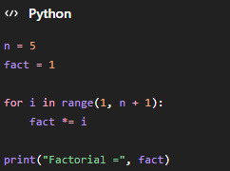

OUTPUT
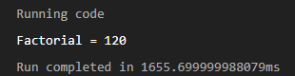
- Conclusion: Both iterative and recursive methods have O(n) complexity. Recursion is elegant but requires additional stack memory.

Experiment 4: Fibonacci Series
- Aim: To generate the first n Fibonacci numbers and analyze the efficiency of iterative generation.
- Algorithm:
  - Initialize two variables with 0 and 1.
  - Print the current value.
  - Generate the next term by adding the previous two terms.
  - Repeat until n terms are generated.
PROGRAM
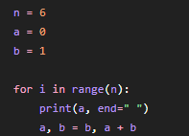

OUTPUT
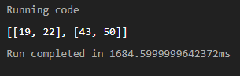
- Conclusion: The iterative Fibonacci algorithm executes in O(n) time and is more efficient than the naive recursive approach.

Experiment 5: Matrix Multiplication
- Aim: To perform matrix multiplication and analyze the complexity of nested loops.
- Algorithm:
  - Read matrices A and B.
  - Initialize the result matrix.
  - Multiply rows and columns using nested loops.
  - Store and print the result matrix.
PROGRAM
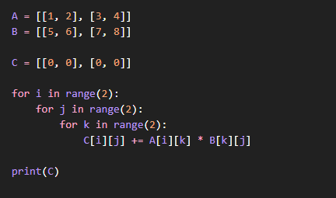

OUTPUT
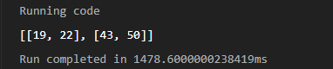
- Conclusion: Matrix multiplication illustrates the use of three nested loops, resulting in O(n³) time complexity.

Experiment 6: Merge Sort
- Aim: To implement Merge Sort and analyze the divide-and-conquer technique.
- Algorithm:
  - Divide the array into two halves.
  - Recursively sort each half.
  - Merge the sorted halves.
  - Display the sorted array.
PROGRAM
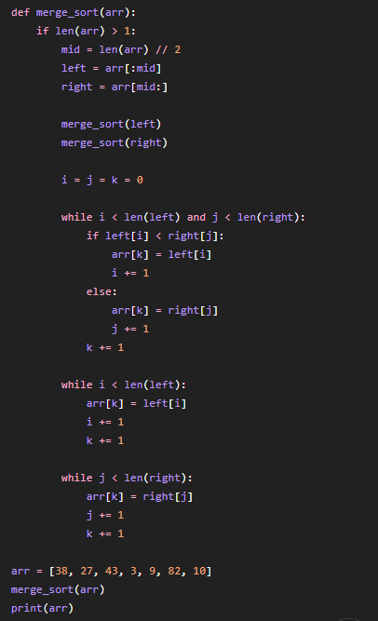
OUTPUT

- Conclusion: Merge Sort guarantees O(n log n) performance and is suitable for large datasets.

Experiment 7: Quick Sort
- Aim: To implement Quick Sort and study the impact of pivot selection on performance.
- Algorithm:
  - Select a pivot element.
  - Partition the array.
  - Recursively sort the partitions.
  - Combine the results.
PROGRAM
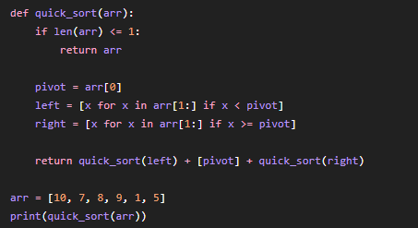

OUTPUT
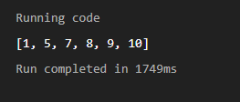
- Conclusion: Quick Sort performs efficiently in practice with an average complexity of O(n log n).

Experiment 8: Tower of Hanoi
- Aim: To solve the Tower of Hanoi problem using recursion and analyze its complexity.
- Algorithm:
  - Move n-1 disks to the auxiliary rod.
  - Move the largest disk to the destination rod.
  - Move the remaining disks to the destination.
PROGRAM
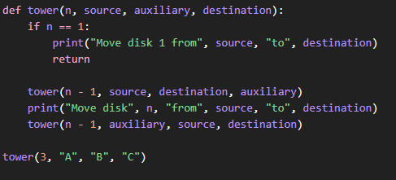

OUTPUT
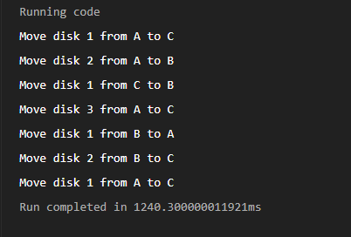
- Conclusion: Tower of Hanoi demonstrates recursive problem-solving and has exponential time complexity O(2ⁿ).

Experiment 9: GCD (Euclidean Algorithm)
- Aim: To determine the Greatest Common Divisor (GCD) of two numbers using Euclid's algorithm.
- Algorithm:
  - Read two integers.
  - Compute the remainder.
  - Repeat until the remainder becomes zero.
  - Return the last non-zero divisor.
PROGRAM
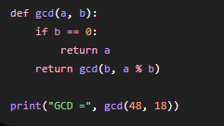

OUTPUT
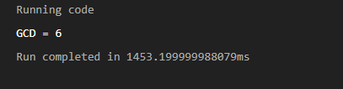
- Conclusion: Euclid's algorithm is one of the most efficient methods for finding GCD with O(log n) complexity.

Experiment 10: Insertion Sort
- Aim: To implement Insertion Sort and analyze its performance.
- Algorithm:
  - Select the next element.
  - Compare it with previous elements.
  - Insert it into the correct position.
  - Repeat until the array is sorted.
PROGRAM
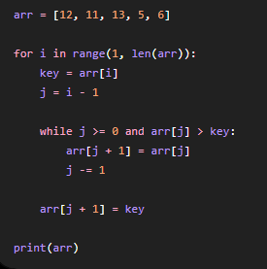
OUTPUT
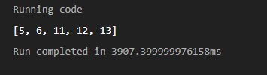
- Conclusion: Insertion Sort is efficient for small or nearly sorted arrays but has O(n²) worst-case complexity.

Experiment 11: Heap Sort
- Aim: To implement Heap Sort and analyze heap-based sorting.
- Algorithm:
  - Build a heap from the input array.
  - Repeatedly remove the root element.
  - Reorganize the heap.
PROGRAM
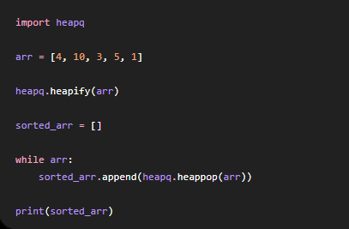
OUTPUT
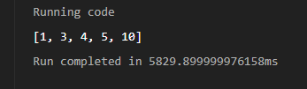
- Conclusion: Heap Sort consistently provides O(n log n) performance regardless of input order.

Experiment 12: Counting Inversions
- Aim: To count the number of inversions present in an array.
- Algorithm:
  - Compare every pair of elements.
  - Increment the count if the first element is greater than the second.
  - Display the total inversion count.
PROGRAM

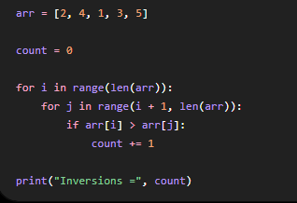

OUTPUT
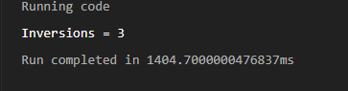
- Conclusion: Counting inversions helps determine how far an array is from being sorted.

Experiment 13: Maximum Subarray Sum
- Aim: To find the maximum possible sum among all contiguous subarrays.
- Algorithm:
  - Initialize current and maximum sums.
  - Traverse the array.
  - Update the current sum.
  - Store the maximum value encountered.
PROGRAM
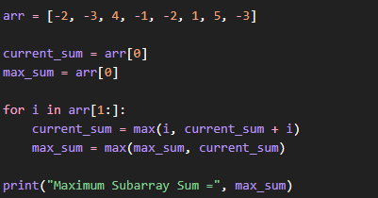
OUTPUT
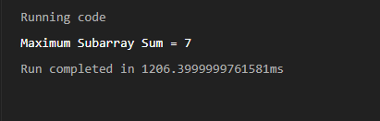
- Conclusion: Kadane's algorithm efficiently solves the problem in linear time, O(n).

Experiment 14: Exponentiation
- Aim: To compute the power of a number using recursive exponentiation.
- Algorithm:
  - Read base x and exponent n.
  - If n is zero, return 1.
  - Recursively compute the power.
  - Display the result.
PROGRAM
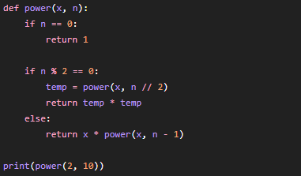

OUTPUT
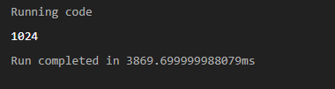
- Conclusion: Fast exponentiation reduces computation time from O(n) to O(log n).

Experiment 15: Closest Pair of Points
- Aim: To determine the closest pair of points in a two-dimensional plane.
- Algorithm:
  - Compute distances between all pairs of points.
  - Keep track of the minimum distance.
  - Display the closest pair and their distance.
PROGRAM
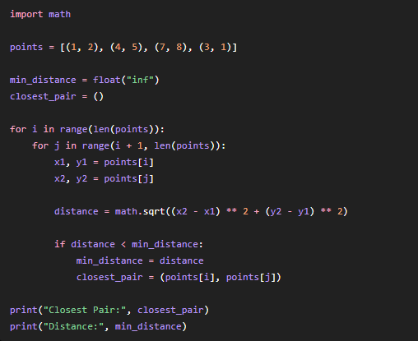
OUTPUT
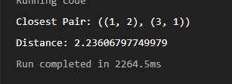

- Conclusion: The brute-force method correctly identifies the closest pair but requires O(n²) time complexity.

